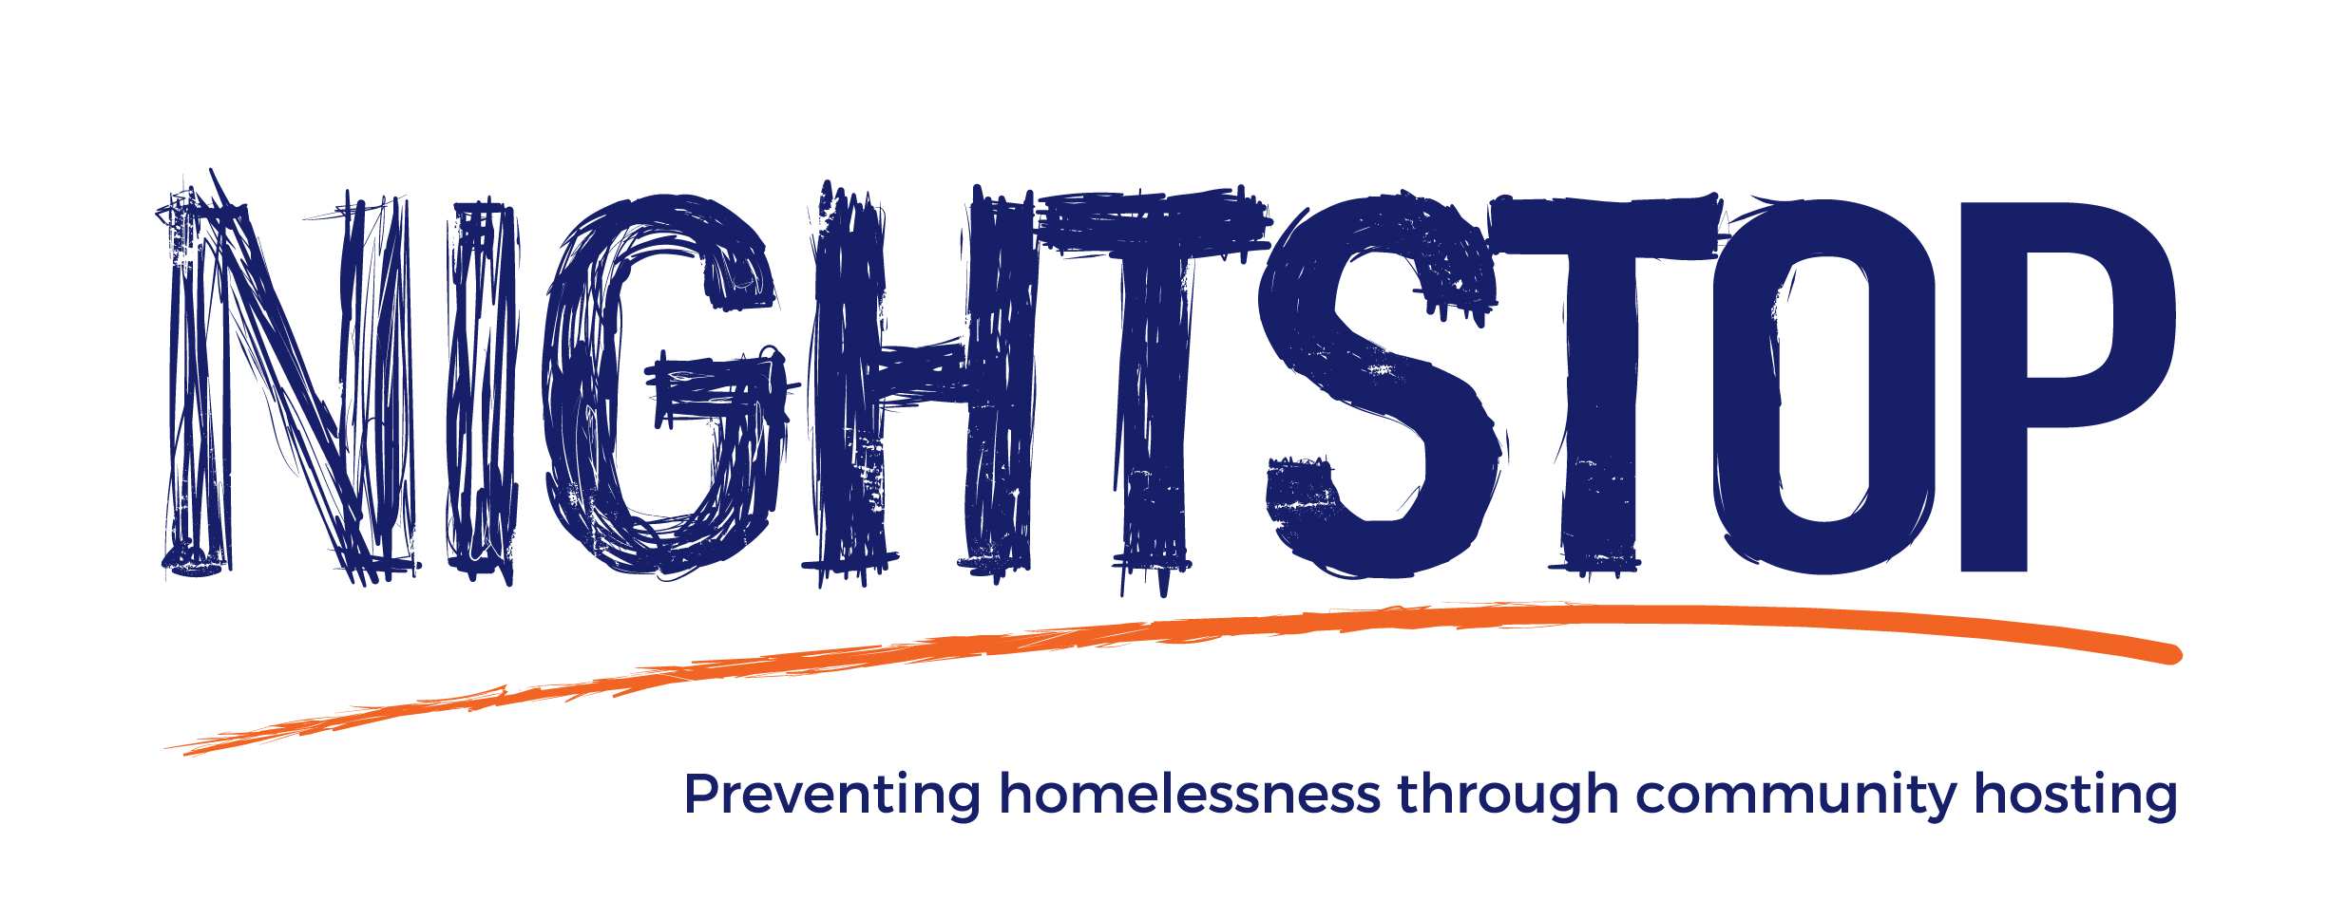

Host Volunteer ROLE DESCRIPTION

Introduction
360°kids supports at-risk youth across York Region through a variety of innovative programs and services. The name 360ºkids references the comprehensive approach that the organization takes to assisting at-risk youth, recognizing that these kids need a wide range of supports to help them rebuild their lives. Ranging from afterschool programs and drop-in centres to employment, housing, counselling and academic programs, the organization is a one-stop-shop for youth support. The organization strives to surround kids in crisis with care by creating communities where every kid matters, and feels safe, supported and loved.

Volunteer Host Role Description

How Nightstop Works:

Nightstop prevents homelessness through community hosting. It helps people who are in immediate housing crisis by providing safe accommodation in the homes of trained and vetted volunteers called ‘Host Volunteers’.
The typical Nightstop model involves guests being hosted on a night-by-night basis. However, in response to the ongoing COVID-19 (aka coronavirus) pandemic we are currently asking hosts to provide longer stays to guests where possible. This has been put in place temporarily to reduce the need for Nightstop guests to travel between households, and therefore support social distancing as far as possible. Whilst the guest is staying with the host longer term appropriate accommodation is sought.

COVID-19 and volunteer eligibility
360°kids has a duty of care not only to the guests we support, but also towards the volunteers that we work with. As the role of Host Volunteer involves a level of in-person contact with Nightstop guests, it is impossible to create an environment that is entirely risk-free. With on-going reference to DePaul UK recommendations and the Ontario Government Guidelines, Nightstop has implemented procedures to minimize risks associated with COVID-19 and will work with volunteer(s) to their level of comfort. With the guidance of Public Health, this condition will be continually reviewed as COVID-19 changes and develops, in the hope that more people will be able to host when it becomes safe for them to do so.
The Volunteer Application form contains a screening section that will help you identify whether you may fall into an at-risk group in relation to COVID-19. This screening tool does not make applicant(s) more or less eligible to volunteer with Nightstop, but can be used as a tool to understand your vulnerability to COVID-19.

Role Description
- To provide guests with a clean, safe and private room.
- To provide guests with an evening meal, breakfast and packed lunch.
- To provide guests with a shower or bath and the opportunity to wash their clothes.
- To liaise with Nightstop Worker(s) regarding availability and to provide regular feedback after each placement.
- To complete initial training program prior to undertaking the role and to participate in periodic training during the course of the role.
- To adhere to the terms of 360°kids policies and its Code of Conduct.
- To contribute positively to the continuous development of the project/ team.
- To observe clear professional boundaries with Nightstop guests.
- To observe appropriate social distancing and hygiene practices to reduce the risk of transmission of COVID-19.

Necessary skills, attitudes and knowledge:
- A desire to work with disadvantaged people.
- A basic understanding of the issues youth face.
- An ability to relate to people on a one-to-one, non-judgmental basis.
- A spare bedroom available for a Nightstop guest to use at short notice.
- A willingness to participate in training and supervision.

Training, support and supervision:
- All Host Volunteer(s) will receive an induction training session and have ongoing training. The volunteer(s) will also have access to all 360°kids training courses if appropriate.
- All Host Volunteer(s) will receive a daily check-in from the Nightstop Worker(s) for the duration of a Nightstop placement, as well as access to 24- hour on-call emergency phone numbers to allow access to advice and guidance.
- All Host Volunteer(s) will be provided with regular support meetings and supervision.

Benefits to the Volunteer:
- Contribute to a service that makes a difference in people’s lives.
- Personal & professional development through training, support and ongoing evaluation.
- Appreciation events to recognize the important contribution that volunteers make.
- All out-of-pocket expenses are reimbursed.

Equality, Diversity and Inclusion:

360°kids believes that no person should be treated less favourably than any other person because of their race, ethnic origin, nationality, religion, disability, sex, age, marital status or sexual orientation.

We are committed to ensuring equality of opportunity for all staff, volunteers and people with whom we work. We believe that selection of Host Volunteers should be based solely on the ability to meet the requirements of the role. We aim to remove discrimination, to provide equal access to opportunities and training, and to ensure that all those who work alongside us enjoy the full benefits of being a Host Volunteer.

Next Steps:
All applicants should complete a Nightstop Volunteer Application Form and will be subject to a Police Vulnerable Sector Check (PVSC), reference checks, an informal interview, completion of training, a home assessment and a home visit prior to being offered the role of a Nightstop Host Volunteer.

